Project Design Phase-II
Technology Stack (Architecture & Stack)

Date | 18 June 2026
Team ID
Project Name | ShopEZ-E-commerce-Application
Maximum Marks | 4 Marks

Technical Architecture:
The Deliverable shall include the architectural diagram as below and the information as per the table1 & table 2
Example:
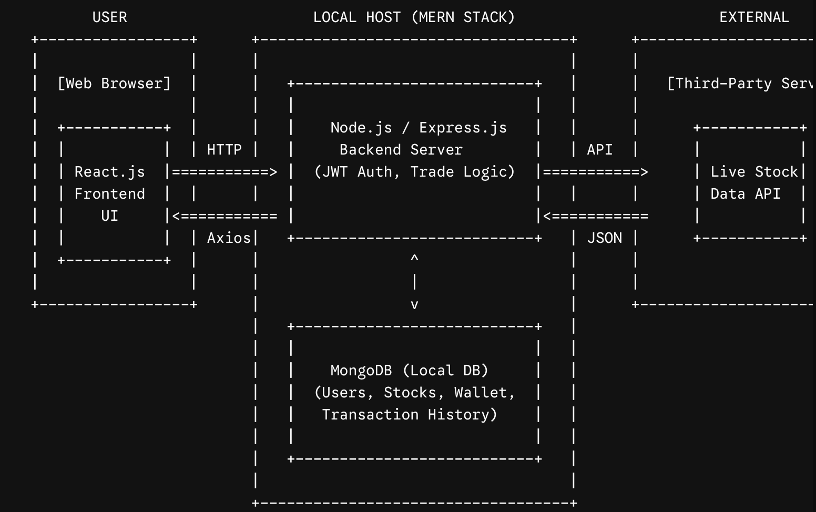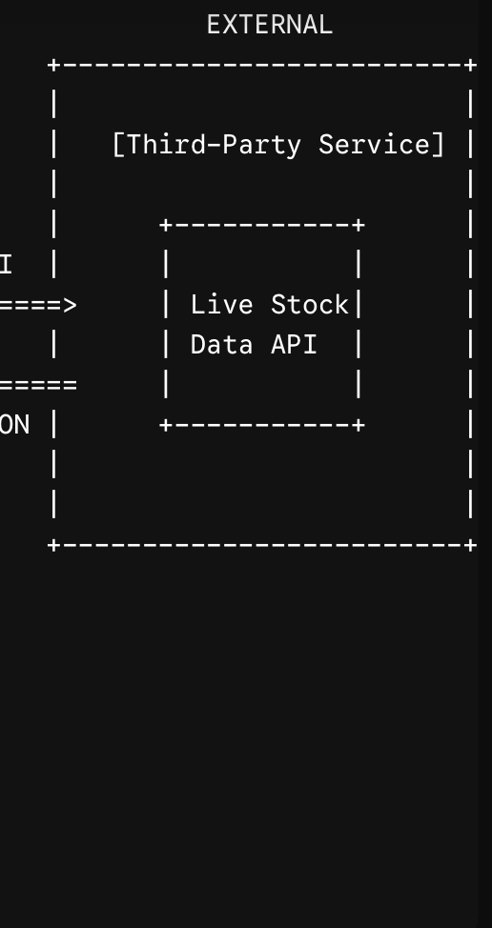
Table-1 : Components & Technologies:
S.No | Component | Description | Technology
 | User Interface | Web-based UI for users to browse stocks, view portfolios, and execute virtual trades.. | React.js, HTML5, CSS3, Bootstrap / Material-UI, Chart.js (or Recharts)
 | Application Logic-1 (Routing & APIs) | Backend framework managing RESTful API routes, user requests, and data flow. | Node.js with Express.js
 | Application Logic-2 (Auth & Security) | Logic for user registration, login, and secure session management. | JWT (JSON Web Tokens), bcrypt.js
 | Application Logic-3 (Market Data) | Logic to fetch, process, and serve live stock data to the frontend. | Axios (HTTP client for API requests)
 | Database | Local database storing Users, Stocks, Transactions, and Portfolio collections. | MongoDB (Local Instance), Mongoose (ODM)
 | Cloud Database | N/A | N/A
 | File Storage | Local storage for project assets, env files, and component logs. | Local Filesystem
 | External API-1 | Real-time stock market data provider to populate the trading dashboard. | Alpha Vantage API / Polygon.io API (or similar financial API).
 | External API-2 | Not currently required for the core MVP. | N/A
 | Machine Learning Model | Not applicable for this project scope. | N/A.
 | Infrastructure (Server / Cloud) | Application development and testing environment. | Localhost (Node.js runtime environment).

Table-2: Application Characteristics:
S.No | Characteristics | Description | Technology
 | Open-Source Frameworks | Core frameworks driving the frontend and backend architecture. | React.js (Frontend library), Express.js (Backend framework)
 | Security Implementations | Access controls to protect user data and ensure secure virtual trading. | JWT for route protection, bcrypt.js for password hashing, CORS middleware
 | Scalable Architecture | The system uses a modular MVC (Model-View-Controller) structure, separating database models, routing, and UI. | MERN Stack (Modular Monolith)
 | Availability | The application relies on the stability of the local Node server and the uptime of the 3rd party Stock API. | Local Node Server (nodemon), Axios for API handling
 | Performance | Efficient state management in the UI and optimized database querying to handle rapid transaction logging. | React State/Hooks, MongoDB Indexing on frequent queries (e.g., Stock Symbols).

